**Volodymyr Kira**

**Module 02 Course Project - Design Your First Home Page**

My site URL:

<http://kirassdns.centralus.cloudapp.azure.com/Fundamentals_of_Mobile_Web_Application_Development/Module_2/project/Homepage/site.html>

URL to my GitHub repository:

<https://github.com/Kiravolodymyr/CIS3801C-Fundamentals-of-Mobile-Web-Application-Development>

Desktop screenshot

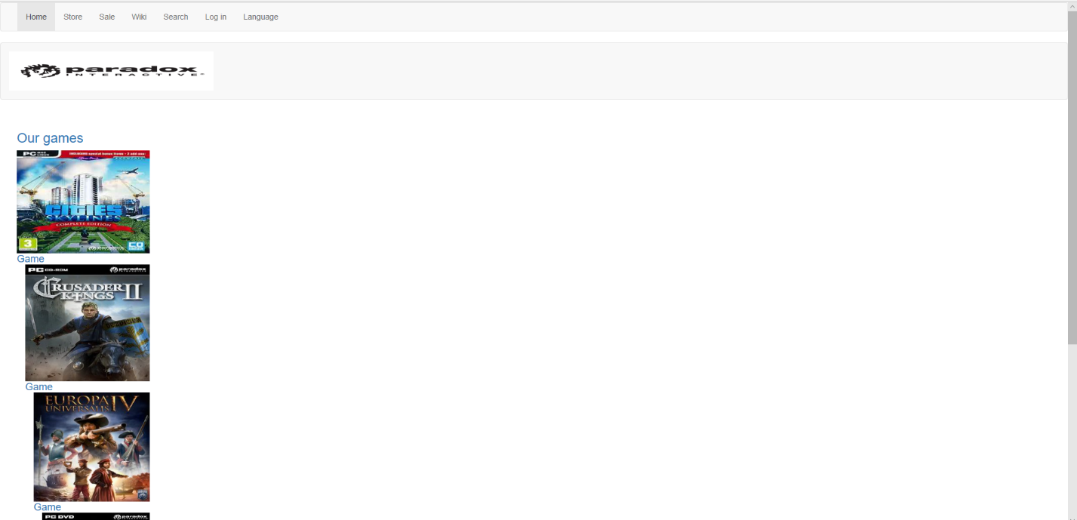

Mobile screenshot

